Database Technologies Lab Sheet — 4
Course Code: MCA105P
Topic: DML Commands, Subqueries, Aggrega ons & Condi onal Logic 50 Prac ce Problems: Sec on A - Easy (20) | Sec on B - Medium (20) | Sec on C - Hard (10) Objective: To understand and apply Data Definition Language (DDL) commands in SQL for creating, modifying, and managing database structures such as tables, columns.
SQL Data Manipulation Language (DML) Lab Exercises Lab Exercise 1:
Basic INSERT Operations Objective:
Part A — Database Setup and Dummy Data Use the following database for the constraint exercises. The order is important: create the parent table first, then the child table.
CREATE DATABASE sql_lab;
USE sql_lab;
CREATE TABLE Department (
DeptID INT PRIMARY KEY,
DeptName VARCHAR(50) NOT NULL );
CREATE TABLE Student (
StudentID INT PRIMARY KEY,
Name VARCHAR(100) NOT NULL,
Email VARCHAR(100),
Age INT,
DeptID INT,
JoiningDate DATE );
CREATE TABLE Enrollment (
EnrollmentID INT PRIMARY KEY,
StudentID INT,
CourseName VARCHAR(100) );

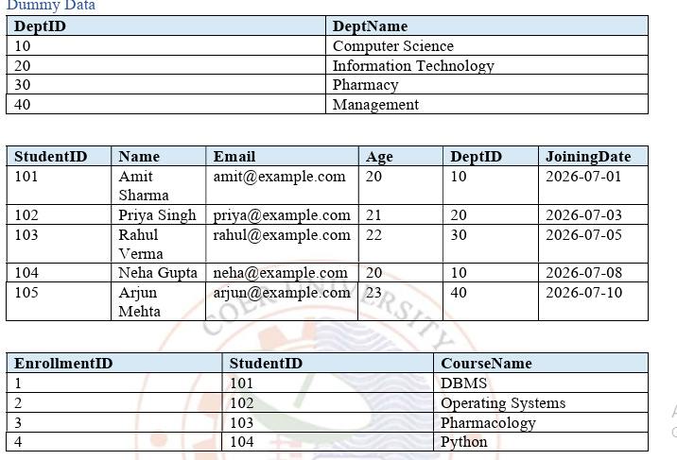
Q-1. Identify the primary key of Department and explain why DeptID is suitable.
2. Create Department so that DeptID is a PRIMARY KEY. Insert the four dummy department records.
3. Create Student so that StudentID is a PRIMARY KEY. Insert the five dummy student records.
4. Try to insert another student with StudentID = 101. What happens?
5. Create Enrollment with EnrollmentID as its PRIMARY KEY and insert the four dummy enrollment records.
6. Try to insert another enrollment with EnrollmentID = 1. What happens?
FOREIGN KEY Questions
7. Add a FOREIGN KEY from Student(DeptID) to Department(DeptID).
8. Add a FOREIGN KEY from Enrollment(StudentID) to Student(StudentID).
9. Try to insert a student with DeptID = 99. Explain the result.
10. Try to insert an enrollment for StudentID = 999. Explain the result.
11. Display students together with their department names using an INNER JOIN. 12. Display enrollment details together with the student name using an INNER JOIN.

use sql_lab;
CREATE TABLE department(
DeptID INT PRIMARY KEY,
DeptName VARCHAR(50) NOT NULL
);
INSERT INTO Department VALUES
(10,'Computer science'),(20,'Information Technology'),
(30,'Pharmacy'),(40,'Managment');

ALTER TABLE Student ADD CONSTRAINT check_student_age CHECK (Age > 18);
INSERT INTO Student VALUES (106,'Riya Das','riya@example.com',17,20,'2026-08-01');
CREATE TABLE Course (
CourseID INT PRIMARY KEY,
CourseName VARCHAR(100),
Credits INT CHECK (Credits BETWEEN 1 AND 6) );
INSERT INTO Course VALUES (1,'DBMS',8);

ALTER TABLE Student ADD COLUMN JoiningDate2 DATE DEFAULT (CURRENT_DATE);
INSERT INTO Student (StudentID,Name,Email,Age,DeptID) VALUES (106,'Riya Das','riya@example.com',21,20);
SELECT * FROM Student;
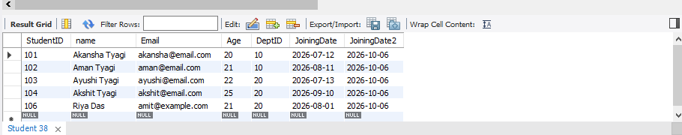

CREATE TABLE Faculty (
FacultyID INT PRIMARY KEY,
FacultyName VARCHAR(100) NOT NULL,
Designation VARCHAR(50) DEFAULT 'Lecturer'
);
INSERT INTO Faculty (FacultyID, FacultyName) VALUES (1,'Dr. Meera Sharma');
SELECT * FROM Faculty;

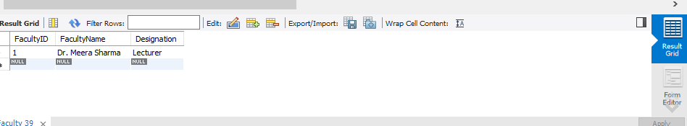

CREATE TABLE employees (
emp_id INT PRIMARY KEY,
name VARCHAR(80),
department VARCHAR(50),
salary DECIMAL(10,2),
hire_date DATE
);

INSERT INTO employees VALUES (101,'John Smith','IT',55000,'2024-01-15');
INSERT INTO employees VALUES
(102,'Sarah Johnson','HR',48000,'2024-02-10'),
(103,'Mike Davis','Finance',52000,'2024-01-20'),
(104,'Lisa Wilson','Marketing',45000,'2024-03-01');

INSERT INTO employees (emp_id,name,department) VALUES (107,'David Clark','Sales');

SELECT*FROM employees;
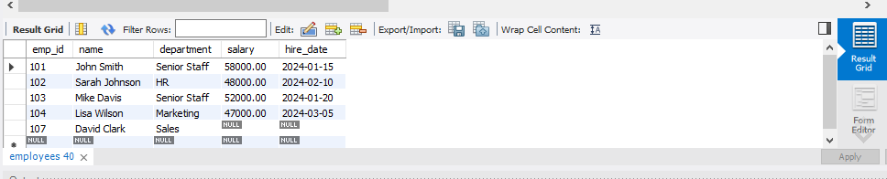
SELECT name, salary FROM employees;
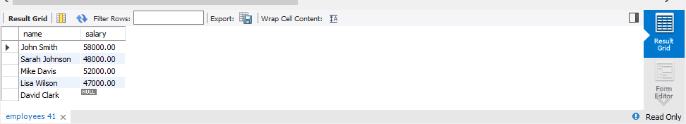
SELECT*FROM employees WHERE department= 'IT';

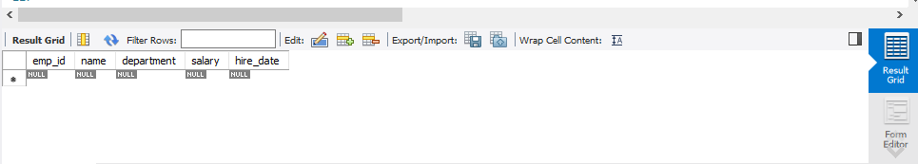
SELECT*FROM employees WHERE hire_date BETWEEN '2024-01-01' AND '2024-01-31';
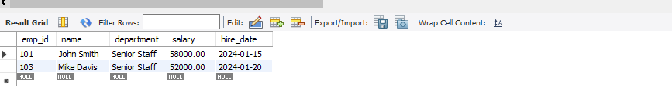
SELECT DISTINCT department FROM employees;

SELECT COUNT(*) AS total_employess FROM employees;
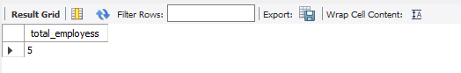
SELECT MAX(salary) AS maximun_salary,MIN(salary) AS minimun_salary, AVG(salary) AS average_salry FROM employees;
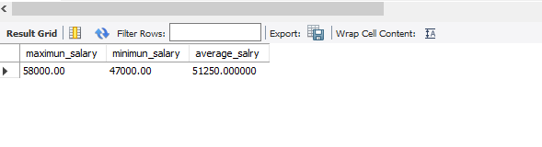
UPDATE employees SET salary = 58000 WHERE name = 'John Smith';
UPDATE empolyees SET salary = salary * 1.05 WHERE department = 'HR';
UPDATE employees SET salary = 47000, hire_date = '2024-03-05' WHERE name = 'Lisa Wilson';
UPDATE employees SET department = 'Operations' WHERE salary> 50000;
UPDATE employees SET salary = 200 + salary WHERE department = 'Finance';
UPDATE employees SET department = 'Senior Staff' WHERE hire_date < '2024-02-01';

CREATE TABLE products (
product_id INT PRIMARY KEY,
product_name VARCHAR(50),
category VARCHAR(50),
price DECIMAL(10,2),
stock_quantity INT
);
INSERT INTO products
(product_id, product_name, category, price, stock_quantity)
VALUES
(1, 'Laptop', 'Electronics', 999.99, 5),
(2, 'Mouse', 'Electronics', 25.50, 0),
(3, 'Desk Chair', 'Furniture', 150.00, 3),
(4, 'Monitor', 'Electronics', 1200.00, 2),
(5, 'Keyboard', 'Electronics', 75.00, 0),
(6, 'Coffee Mug', 'Office', 12.99, 10),
(7, 'Notebook', 'Office', 5.99, 8),
(8, 'Smartphone', 'Electronics', 1500.00, 1);
SELECT*FROM products;
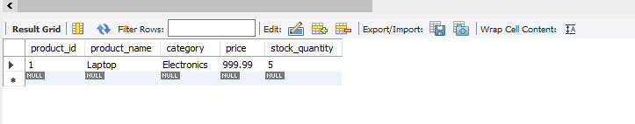
DELETE FROM products WHERE stock_quantity = 0;
DELETE FROM products WHERE category='Electronics' AND price >1000;
DELETE FROM products WHERE product_name = 'Desk Chair';
DELETE FROM products WHERE price<100;

CREATE TABLE students (
student_id INT PRIMARY KEY,
student_name VARCHAR(50),
course VARCHAR(50),
marks INT,
city VARCHAR(50)
);
INSERT INTO students
(student_id, student_name, course, marks, city)
VALUES
(1, 'Alice Brown', 'Computer Science', 85, 'Mumbai'),
(2, 'Bob Wilson', 'Mathematics', 92, 'Delhi'),
(3, 'Carol Davis', 'Computer Science', 78, 'Mumbai'),
(4, 'David Miller', 'Physics', 88, 'Chennai'),
(5, 'Eva Garcia', 'Mathematics', 95, 'Delhi'),
(6, 'Frank Johnson', 'Computer Science', 82, 'Bangalore'),
(7, 'Grace Lee', 'Physics', 90, 'Mumbai'),
(8, 'Henry Smith', 'Mathematics', 76, 'Chennai'),
(9, 'Ivy Chen', 'Computer Science', 89, 'Delhi'),
(10, 'Jack Taylor', 'Physics', 84, 'Bangalore');
select*from students;
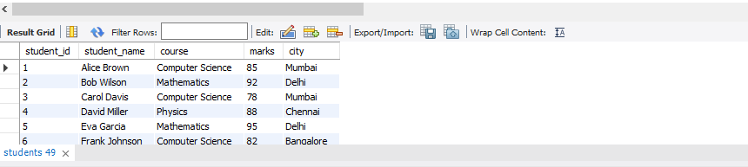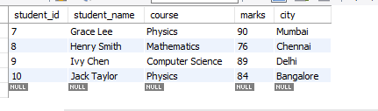
SELECT * FROM student ORDER BY marks DESC;
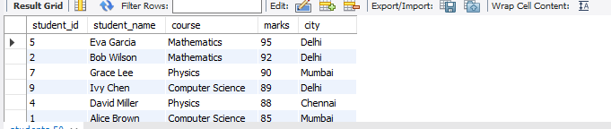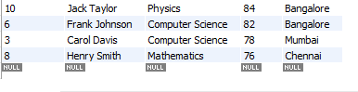
select*from students ORDER BY marks DESC LIMIT 5;
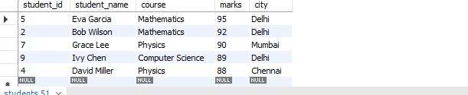
select*from students where course = 'Computer Science' ORDER BY student_name ASC;
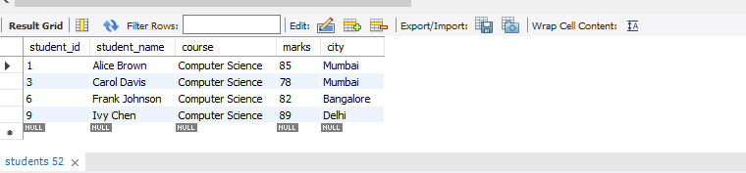
select*from students ORDER BY marks ASC LIMIT 3;
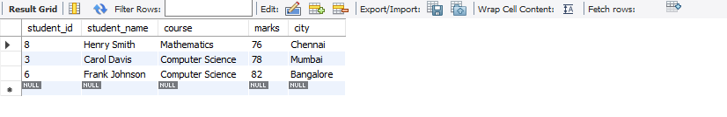
select*from students where marks BETWEEN 80 AND 90;
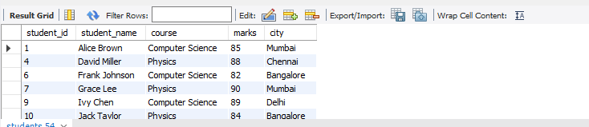
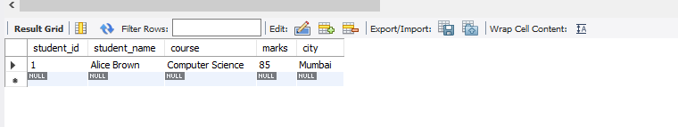select*from students where student_name LIKE 'A%';
CREATE TABLE Books (
book_id INT PRIMARY KEY,
title VARCHAR(255) NOT NULL,
author VARCHAR(255),
isbn VARCHAR(13) UNIQUE,
genre VARCHAR(50)
);
CREATE TABLE Members (
member_id INT PRIMARY KEY,
name VARCHAR(255) NOT NULL,
email VARCHAR(255) UNIQUE,
phone_number VARCHAR(20)
);
CREATE TABLE Loans (
loan_id INT PRIMARY KEY,
book_id INT,
member_id INT,
loan_date DATE,
return_date DATE NULL,
FOREIGN KEY (book_id) REFERENCES Books(book_id),
FOREIGN KEY (member_id)
REFERENCES Members(member_id)
);

INSERT INTO Books VALUES
(1,'Database System Concepts','Korth','9780073523323','Database'),
(2,'Operating System Concepts','Silberschatz','9781119456339','OS'),
(3,'Python Crash Course','Eric Matthes','9781718502703','Programming');

INSERT INTO Members VALUES
(101,'Amit Sharma','amit.lib@example.com','9876500001'),
(102,'Priya Singh','priya.lib@example.com','9876500002'),
(103,'Rahul Verma','rahul.lib@example.com','9876500003');

INSERT INTO Loans VALUES
(1,1,101,'2026-09-01',NULL),
(2,2,102,'2026-09-02','2026-09-06'),
(3,3,103,'2026-09-04',NULL);

SELECT l.loan_id, b.title, m.name, l.loan_date, l.return_date
FROM Loans l
INNER JOIN Books b ON l.book_id = b.book_id
INNER JOIN Members m ON l.member_id = m.member_id;
